**Design an android activity with two text boxes where the user can enter (username and ID) and a button (validate). Validate the entered username and ID field for the following using android code.**

**AIM:**

**To implement an android application to Validate the entered username and ID field.**

**PROCEDURE:**

**Step 1: File → New Project Provide the application name and Click “Next”**

**Step 2: Select the target android devices, Select the minimum SDK to run the application. Click “Next”.**

**Step 3: Choose the activity for the application (By default choose “Blank Activity). Click “Next”.**

**Step 4: Enter activity name and click "Finish".**

**Step 5: Edit the program. Step 6: Run the application, 2-ways to run the application**

**1. Running through emulator**

**2. Running through mobile device**

**CODE:**

**activity_main.xml:**

**<?xml version="1.0" encoding="utf-8"?>**

**<androidx.constraintlayout.widget.ConstraintLayout**

**xmlns:android="http://schemas.android.com/apk/res/android"**

**xmlns:app="http://schemas.android.com/apk/res-auto"**

**xmlns:tools="http://schemas.android.com/tools"**

**android:layout_width="match_parent"**

**android:layout_height="match_parent"**

**tools:context=".MainActivity">**

**<EditText**

**android:id="@+id/etUsername"**

**android:layout_width="0dp"**

**android:layout_height="wrap_content"**

**android:layout_marginTop="16dp"**

**android:hint="Enter Username"**

**android:inputType="textPersonName"**

**android:padding="12dp"**

**app:layout_constraintTop_toTopOf="parent"**

**app:layout_constraintStart_toStartOf="parent"**

**app:layout_constraintEnd_toEndOf="parent"**

**android:layout_marginHorizontal="16dp" />**

**<EditText**

**android:id="@+id/etID"**

**android:layout_width="0dp"**

**android:layout_height="wrap_content"**

**android:layout_marginTop="16dp"**

**android:hint="Enter ID"**

**android:inputType="number"**

**android:padding="12dp"**

**app:layout_constraintTop_toBottomOf="@id/etUsername"**

**app:layout_constraintStart_toStartOf="parent"**

**app:layout_constraintEnd_toEndOf="parent"**

**android:layout_marginHorizontal="16dp" />**

**<Button**

**android:id="@+id/btnValidate"**

**android:layout_width="wrap_content"**

**android:layout_height="wrap_content"**

**android:layout_marginTop="24dp"**

**android:text="Validate"**

**app:layout_constraintTop_toBottomOf="@id/etID"**

**app:layout_constraintStart_toStartOf="parent"**

**app:layout_constraintEnd_toEndOf="parent" />**

**<TextView**

**android:id="@+id/tvResult"**

**android:layout_width="0dp"**

**android:layout_height="wrap_content"**

**android:layout_marginTop="16dp"**

**android:padding="8dp"**

**android:text=""**

**android:textColor="@android:color/black"**

**android:textSize="16sp"**

**app:layout_constraintTop_toBottomOf="@id/btnValidate"**

**app:layout_constraintStart_toStartOf="parent"**

**app:layout_constraintEnd_toEndOf="parent" />**

**</androidx.constraintlayout.widget.ConstraintLayout>**

**MainActivity.java:**

**package com.example.validationapp;**

**import android.os.Bundle;**

**import android.text.TextUtils;**

**import android.view.View;**

**import android.widget.Button;**

**import android.widget.EditText;**

**import android.widget.TextView;**

**import android.widget.Toast;**

**import androidx.appcompat.app.AppCompatActivity;**

**public class MainActivity extends AppCompatActivity {**

**private EditText etUsername, etID;**

**private TextView tvResult;**

**@Override**

**protected void onCreate(Bundle savedInstanceState) {**

**super.onCreate(savedInstanceState);**

**setContentView(R.layout.activity_main);**

**// Initialize Views**

**etUsername = findViewById(R.id.etUsername);**

**etID = findViewById(R.id.etID);**

**tvResult = findViewById(R.id.tvResult);**

**Button btnValidate = findViewById(R.id.btnValidate);**

**// Set Validation Button Click Listener**

**btnValidate.setOnClickListener(this::validateInputs);**

**}**

**private void validateInputs(View view) {**

**// Get input values**

**String username = etUsername.getText().toString().trim();**

**String id = etID.getText().toString().trim();**

**// Validation rules**

**if (TextUtils.isEmpty(username)) {**

**showToast("Username cannot be empty");**

**tvResult.setText("Validation Failed: Username is empty.");**

**return;**

**}**

**if (username.length() < 3) {**

**showToast("Username must be at least 3 characters long");**

**tvResult.setText("Validation Failed: Username too short.");**

**return;**

**}**

**if (TextUtils.isEmpty(id)) {**

**showToast("ID cannot be empty");**

**tvResult.setText("Validation Failed: ID is empty.");**

**return;**

**}**

**try {**

**Integer.parseInt(id); // Check if ID is numeric**

**} catch (NumberFormatException e) {**

**showToast("ID must be a number");**

**tvResult.setText("Validation Failed: ID is not numeric.");**

**return;**

**}**

**// If validation passes**

**showToast("Validation Successful!");**

**tvResult.setText("Validation Successful: Username and ID are valid.");**

**}**

**private void showToast(String message) {**

**Toast.makeText(this, message, Toast.LENGTH_SHORT).show();**

**}**

**}**

**OUTPUT:**

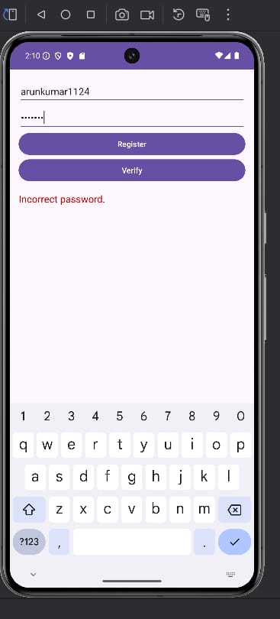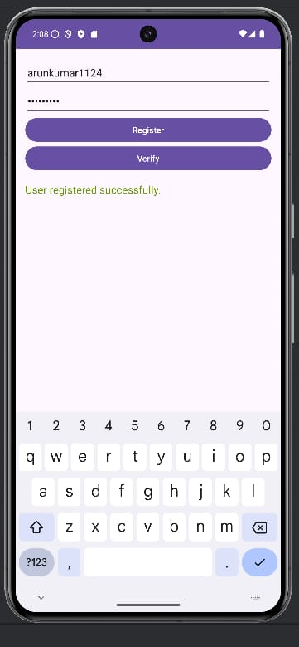

**RESULT:**

**THE PROGRAM IS CREATED AND EXECUTED SUCCESSFULLY.**